Developer Guide

jWebSocket
Remote Shell Demo
1.0

Author?

- Introduction
Remote Shell Demo is an application that allows remote control of computers in real time via the web. Making it easier for users to control the resources of a remote machine using a web interface that reflects the results in real time. It is an application that works on WebSocket communication protocol, which in conjunction with the jWebSocket framework provides precise results and high levels of speed and scalability.
jWebSocket is the framework on top of which the application was developed, showing the potential that it offers to make Web applications in real time.
- Infrastructure of the solution
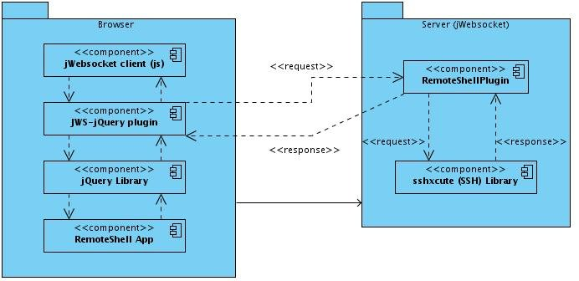

- The application sends and receives data via jQuery plugin JWS-which uses jWebSocket client written in JavaScript.
- The jWebSocket client communicates with the jWebSocket server via WebSocket protocol.
- The server contains the jWebSocket RemoteShellPlugin which manages the communication between the client and the remote machine.
- The plug-in in the server uses the library ssxcute to run the commands that were send from the client, get the results of their execution and sent to the client where they are finally shown.
- Modularization of the application
Server side:
Project name: | Remote Shell Demo
Location of the sources in the SVN server: | https://jwsdev.org:9443/svn/jWebSocket/thesis/RemoteShellDemo/Implementation
SVN branch: | jWebSocket-1.0
Maven Dependency: | 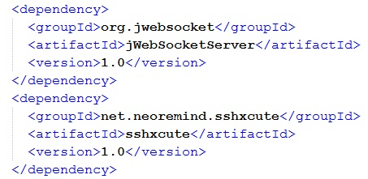
JAR Module: | jWebSocketRemoteShellPlugIn-1.0.jar
Packet structure: | namespaces: org.jwebsocket.plugins.remoteshelldemo  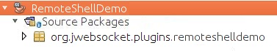
org.jwebsocket.plugins.remoteshelldemo:
Contains the core classes of the module that allows remote management of computers for jWebSocket framework.

The name is jWebSocketRemoteShellPlugin, the dependency cannot be resolved in the implementation, I created a maven repository in our google code to fix that. Please document how to resolve ths dependency to enabkle to user to compile it.
Please refer to the repository section in the parent pom.xml, as described in my feedback mail! Otherwise this cannot be used by the user.
The RemoteShellPlugin needs to be integrated in our standard SVN environoment as a plug-in. I prepared that already, please update from SVN

Client side:
The client libraries and classes for Remote Shell Demo are available only to the JavaScript language and are stored in the folder jWebSocket/thesis/RemoteShellDemo/Implementation/Client.
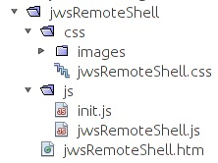

On the client side makes uses the following JavaScript file:
- jwsRemoteShell.js: Can handle the features of the console with the data coming from the server. Add brief description was is done in this file.
Also makes use of css and html files for the application user interface:
- jwsRemoteShell.html: In this file is defined all html code. Screenshot? html or htm (like standard)?
- jwsRemoteShell.css: In this file is defined de css code of the application What special styles are defined here? Purpose?
- I See may more references in the client code as mentioned in my feedback mail. This needs to be cleaned up and the documentation needs to be adjusted accordingly. (e.g. wAction and others, see mail).
- Structure of Source Code
Server side:
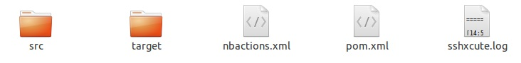
Elements description:
- src: This directory contains all the source code of classes and libraries of the solution.
- target: This directory temporarily stores the compiled source code, its content is not included in the version control.
- nbactions.xml: Project configuration file created by the NetBeans IDE. The contents of this file may or may not be in version control, to include depends on the decision of the development team. It should NOT be included, since it refers to local settings!
- pom.xml: Configuration file for jWebSocketServer module that contains information about the project and details of the settings used by Maven to build the project. Dependencies and repositories? See comments above.
- sshxcute.log: File where the library stores the logs of the application. This should be stored at ${JWEBSOCKET_HOME}logs/…

Client side:
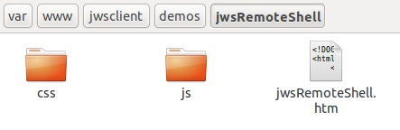
Elements description:
- css: This directory contains the css file and a directory with the images used in the application. Content?
- js: This directory contains the js file used for application development.
- jwsRemoteShell.htm: It is a hypertext file. These are usually static content, not dynamic. Includes the HTML of the application.
Isn’t it better to first describe the folders and subsequently the contents of the folder, please rethink the document structure here.

I miss the Token reference.
I miss the JavaScript Docs
I miss the Java Docs

